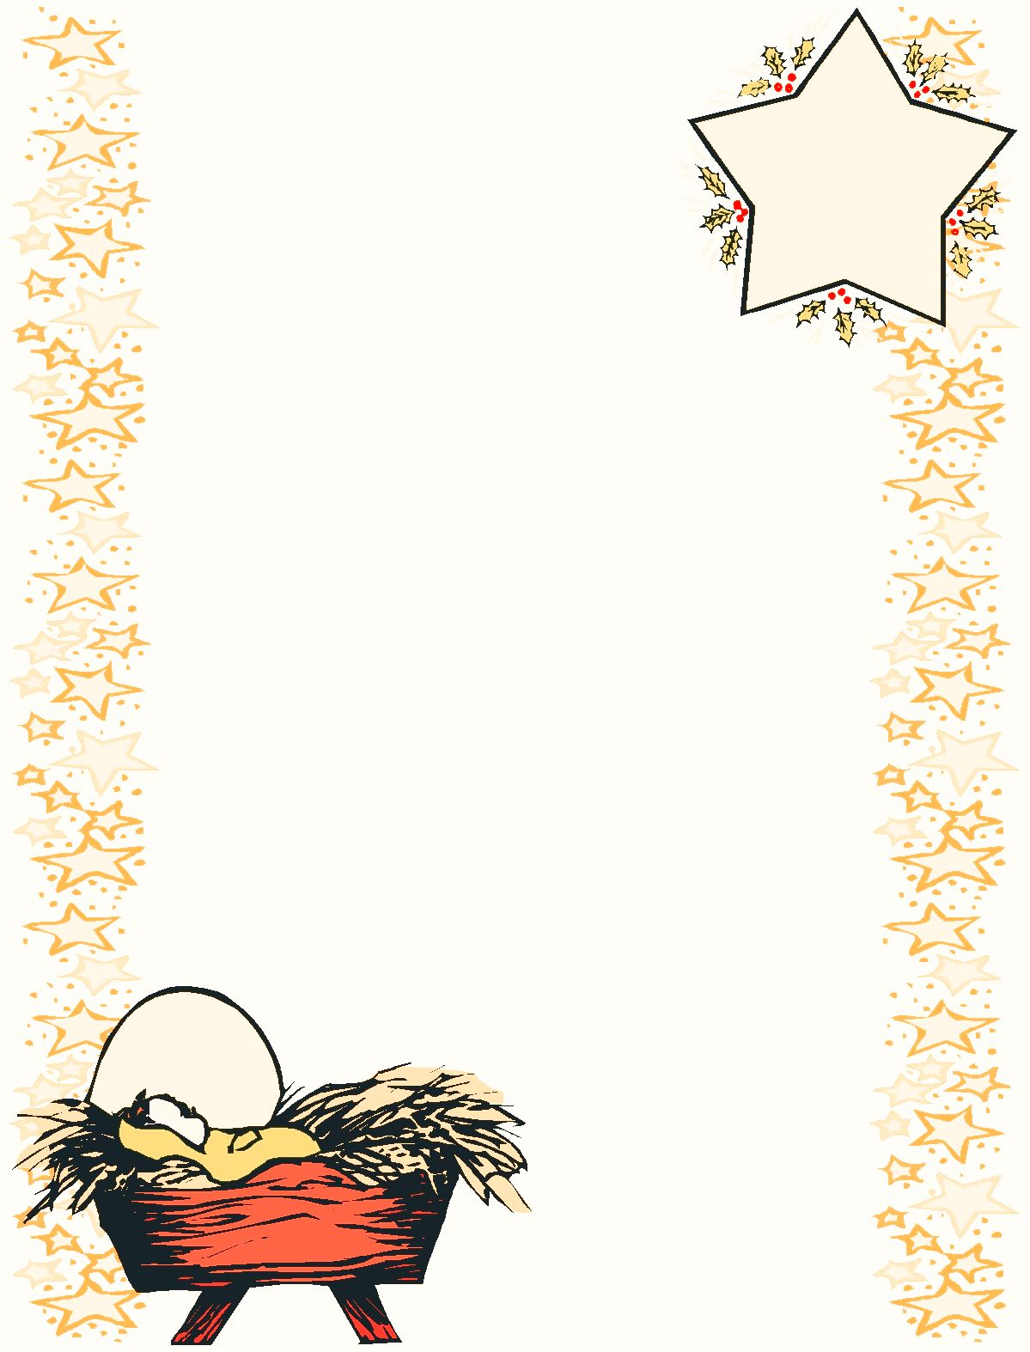

Hello Parents…

**We will be trying something new this month…**

To help the children feel excitement for this program and have

the excitement carry over to completion of the assignment we

will no longer send all the journals home at the same time

but will instead only send 3 journals at a time. Another

change is that we will be sending home an actual story book!

**This is how the new Bag Buddy Program will work…**

We draw three children’s names at random. When your child’s

name is drawn they will get to bring their bag buddy home to work on

with their families. You will have 1-2 days to complete the work and then

return your child’s completed journal (with the folder), the stuffed animal, and the story book back to school. If you are not able to finish within the 1-2 days please just return everything back to school and we will give your child another turn later this month. We are trying to make sure that all 24 children get their turn before the end of the month.

If there is a specific day that you are not able to work on this project at home PLEASE send me a message and I will make sure that it isn’t sent home on that day.

**Please follow these rules….**

1. Please **return the Bag buddy, Journal, and book back to school within 1-2 day**s so that it can be sent home with the next child.
2. **Please don’t do the writing for your children.** You may write the word on a separate piece of paper for your child to copy or, if they know their letters, you can tell them aloud what letters they need to write.
3. It needs to be fun so if they aren’t in the mood then just return it to school and we will give them a turn on a different day.
4. Bag Buddy is story based as a way to encourage a love of reading so a major component of the Bag Buddy program is reading the story. We have already read the story together at school when Bag Buddy was introduced but repetition is key for reading so please read the story with your child at home. I know that your child would really enjoy sharing the story with you at home!